
Department of BES-1
DATA STRUCTURES THROUGH PYTHON(24SC1204)
I/IV-B.Tech-(II Sem), Academic Year: 2024-2025

Session-35 (ADJCENCY LIST REPRESENTATION OF GRAPH)
Instructional Objective:
- To learn the adjacency list representation of graph.
- To represent the Graph in adjacency list form.
Learning Outcomes:
- Students come to understand linked list representation of graph.

Introduction:
Adjacency list
The other way to represent a graph is by using an adjacency list. An adjacency list is an array A of separate lists. Each element of the array A_{i} is a list, which contains all the vertices that are adjacent to vertex i.
For a weighted graph, the weight or cost of the edge is stored along with the vertex in the list using pairs. In an undirected graph, if vertex j is in list Ai then vertex i will be in list Aj.
The space complexity of adjacency list is O(V + E) because in an adjacency list information is stored only for those edges that actually exist in the graph.
Explanation:
Consider the same undirected graph(Fig-1) from an adjacency matrix. The adjacency list of the graph is as follows:
A1 → 2 → 4
A2 → 1 → 3
A3 → 2 → 4
A4 → 1 → 3
Consider the same directed graph(Fig-2) from an adjacency matrix. The adjacency list of the graph is as follows:
A1 → 2
A2 → 4
A3 → 1 → 4
A4 → 2

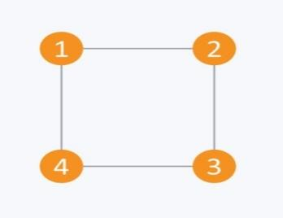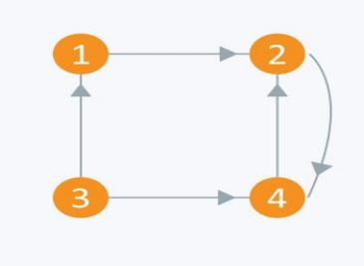
Fig-1 Fig-2.
Review questions:
- What is the adjacency list representation of a graph and how does it differ from the adjacency matrix representation?
Summary:
In this session, it was discussed about Adjacency list representation of Graph.

Self-assessment questions:
1.Space complexity for an adjacency list of an undirected graph having large values of V (vertices) and E (edges) is ___________
a)O(E)
b)O(V*V)
c)O(E+V)
d) O(V)

2.In which case adjacency list is preferred in front of an adjacency matrix?
a) Dense graph
b) Sparse graph
c) Adjacency list is always preferred
d) Complete graph

Terminal questions
CLASSROOM DELIVARY PROBLEMS
1.Draw the adjacency list representation of the following undirected graph?

PRACTICE PROBLEMS

1.Draw the adjacency list representation of the following Directed Graph.

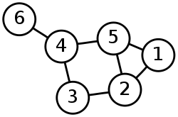

TUTORIAL PROBLEMS
1.Draw the adjacency list representation of the following graph?

Draw the weighted directed graph represented by the adjacency matrix below. A non- zero value at [row, column] indicates that the vertex in the row is adjacent to the vertex in the column:
